**Comparing proportion of habitat in range and mean proportion habitat in point occurrence buffers**

Rondinini et al. (2011) created deductive habitat suitability models (high, medium, unsuitable) for >5000 terrestrial mammals globally at a spatial grain of 300 meters to examine patterns of richness and protection. They conducted model evaluation on a subset of only 263 species because detailed occurrence data are lacking for most mammal taxa. The occurrence data used contains information on species presence only, limiting assessment methodologies. Therefore, Rondinini et al. chose to compare what they term ‘model prevalence’ and ‘point prevalence’ to species’ landscapes of randomly distributed habitat at a spatial grain of 1 km2 (the assumed accuracy of their point locality data). Point prevalence is defined as the proportion of 1 km2 cells containing one or more occurrences and one or more 300 m cells with high and/or medium suitability (i.e. proportion of correctly predicted occurrences). Model prevalence is defined as the proportion of 1 km2 cells with high or medium suitability within the species’ range. The results of their evaluation produced the following chart:

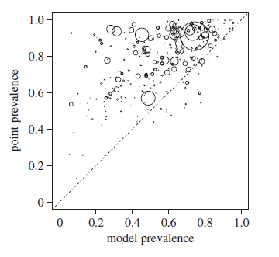

As Rondinin et al. describe: *“If predicted suitable cells were distributed randomly with respect to species occurrences, the expectation would be that the point prevalence equals the model prevalence.”* Hence, the comparison assumes a random habitat landscape is one in which any given location contains habitat at proportions equal to model predicted habitat across the entire species’ range. When point prevalence is greater than model prevalence, the model predicts habitat at species locations better than the range *“because it tends to correctly flag as unsuitable the cells that do not contain occurrences.”*

GAP species maps include geographic range along with distribution of potential habitat generated at a spatial raster resolution of 30 m. Therefore, each species has a measurement of model prevalence, which is simply the areal proportion of predicted habitat within the delineated range. However, in order to calculate point prevalence at a 30 m spatial grain, point occurrences would need to have an equivalent spatial accuracy. Point prevalence calculations at a 30 m spatial grain will be available only for a very limited number of species and with very few data points because most point occurrence datasets (e.g. GBIF, BiSON, eBird) have either no information regarding individual location accuracy or vary widely in coordinate uncertainty (e.g. <100 m to province-level centroids). However, buffering point occurrences by the degree of uncertainty of presence locations and calculating the proportion of habitat within those buffers would allow for comparisons to random habitat landscapes using range alone. As with point prevalence vs. model prevalence, models that predict habitat better than random would have a mean proportion of habitat in point buffers greater than the proportion of habitat throughout the species’ range.

The following is an illustration of this assessment method for the Black-bellied salamander (*Desmognathus quadramaculatus*). The range for this species extends throughout the southern Appalachian Mountains from West Virginia to northern Georgia. GBIF records were obtained that have latitude and longitude coordinates with a measure of accuracy (uncertainty). The GAP mapped range and habitat along with the 174 GBIF records are pictured below where the gray polygon is the GAP range, green pixels are predicted habitat, and the black cross symbols are GBIF records. Model prevalence (proportion of GAP predicted habitat in range) for this species is 0.0401.

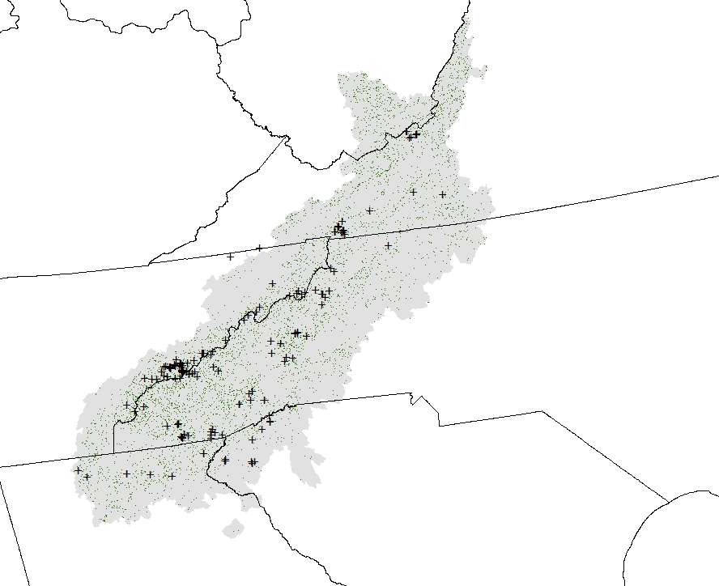

Each occurrence location has a coordinate uncertainty measured in meters, which was used to generate circular buffers around each point. Occurrence locations with coordinate uncertainty less than 30 meters were buffered at 30 meters and only points with a coordinate uncertainty of 10000 meters or less were used in the assessment.

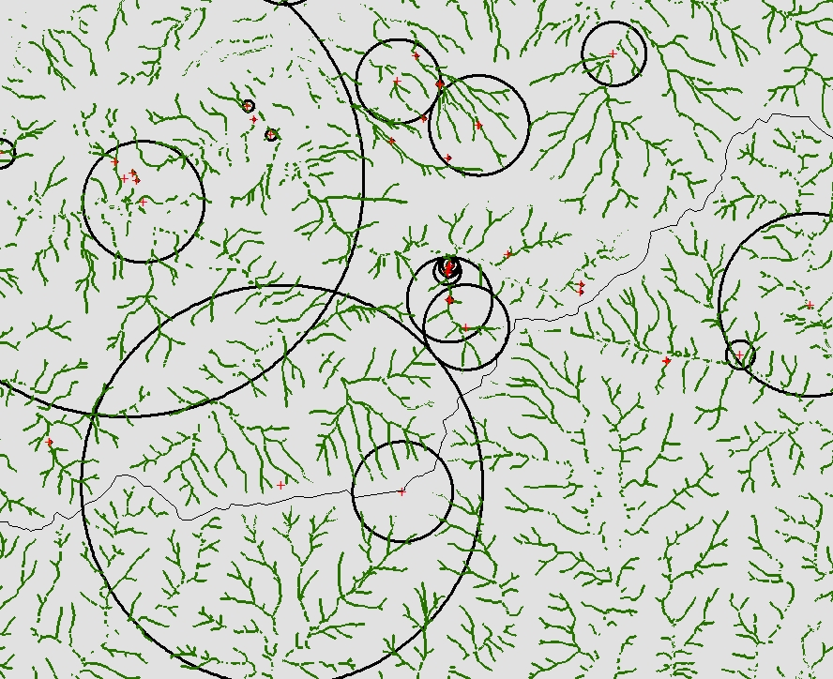

The proportion of predicted habitat amount was calculated for each point buffered area. The histogram of point buffer habitat proportions:

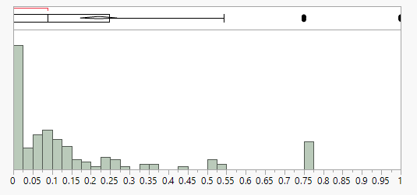

Interestingly, the relationship of point buffer radius (buffer distance) appears to be negatively related to habitat proportion within the buffer:

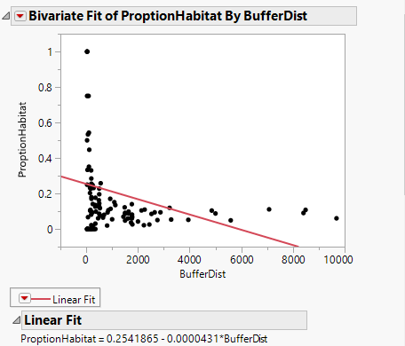

The mean proportion of habitat in point buffers was calculated and plotted against the proportion of habitat in the species’ range ( $\overline{x}$ = 0.2204; approximately 5 times greater than proportion of habitat in range). Similar calculations were made for locations and their associated buffer distances for 10 additional species across a continuum of model prevalences (proportion of habitat in range) illustrating most species have models considered ‘better than random’.

~~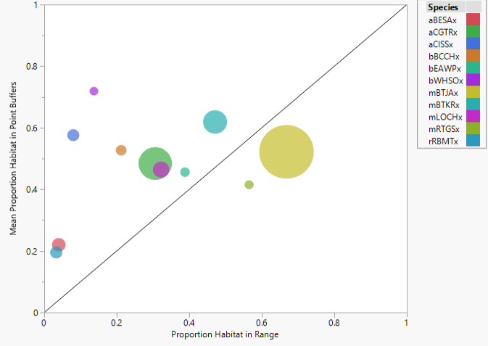~~

Note: the size of the circles is proportional to the number of point occurrence records used to make the habitat proportion comparison for each species.

Species codes in the above graph are as follows:

|  |  |  |  |  |
| --- | --- | --- | --- | --- |
| **Species Code** | **Scientific Name** | **Common Name** | **Prop. Hab. in Range** | **Prop. Hab. in Point Buffers** |
| aBESAx | Desmognathus quadramaculatus | Black-bellied Salamander | 0.040 | 0.220 |
| aCGTRx | Hyla chrysoscelis | Cope's Gray Treefrog | 0.306 | 0.484 |
| aCISSx | Batrachoseps pacificus | Channel Islands Slender Salamander | 0.080 | 0.576 |
| bBCCHx | Poecile atricapillus | Black-capped Chickadee | 0.212 | 0.527 |
| bEAWPx | Contopus virens | Eastern Wood-pewee | 0.388 | 0.456 |
| bWHSOx | Megascops trichopsis | Whiskered Screech-owl | 0.137 | 0.719 |
| mBTJAx | Lepus californicus | Black-tailed Jackrabbit | 0.668 | 0.522 |
| mBTKRx | Dipodomys spectabilis | Banner-tailed Kangaroo Rat | 0.471 | 0.619 |
| mLOCHx | Tamias speciosus | Lodgepole Chipmunk | 0.322 | 0.464 |
| mRTGSx | Spermophilus tereticaudus | Round-tailed Ground Squirrel | 0.565 | 0.415 |
| rRBMTx | Sternotherus carinatus | Razor-backed Musk Turtle | 0.033 | 0.195 |

Rondinini, C., Di Marco, M., Chiozza, F., Santulli, G., Baisero, D., Visconti, P., ... Boitani, L. (2011). Global habitat suitability models of terrestrial mammals. Philosophical Transaction of the Royal Society B: Biological Sciences, 366, 2633-2641.

NOTES

Here is a proposed workflow to conduct these analyses using scripting. Using Python, the workflow would require the [**pygbif**](https://pygbif.readthedocs.io/en/latest/index.html) and [**python-dwca-reader**](https://python-dwca-reader.readthedocs.io/en/latest/index.html) packages as well as Pandas for dataframe manipulation. Utilizing the **pygbif** package would be exclusive to accessing the GBIF API and would require the user to have an account, along with username and password, to access the functionality of downloading GBIF occurrences programmatically.

* Create a script, function, or module that downloads GBIF occurrences. Note that using the occurrences.search functionality of **pygbif** is limited to 300 records/page and 200,000 records/request. Using the occurrences.download function with a username and password is not limited to 200,000 records/request.
* Create a script(s), function(s), or module that processes downloaded GBIF records to filter records accordingly. Flexibility of these programmatic methods would be necessary to account for various taxa and provide utility to other types of analyses.
* Create a script(s), function(s), or module that creates spatial versions of the occurrence data based on the latitude and longitude and coordinate uncertainty of the occurrences. That is, vector datasets of points and point buffers.
* Create a script, function, or module that performs spatial analyses between point buffers and species’ habitat rasters to calculate and compare for each species the mean proportion of habitat within point buffers and the proportion of habitat within the species’ range (model prevalence).